**Demo Project**

1) Persistent tab view package screen:

Search about this package to let the bottom navigation fixed over the whole app with navigation from screen to screen, you will use it after login and forget password scenario.

2) Login screen:

1. You will use a phone number and password for a given account to login via it.
2. When two fields are empty the login button will be in gray color and disable it’s click action, when they are filled with data you will make this button with the activate color.
3. You will make the password field hidden with black bullets or not when clicking on the eye icon also the eye icon changes when clicking on it.

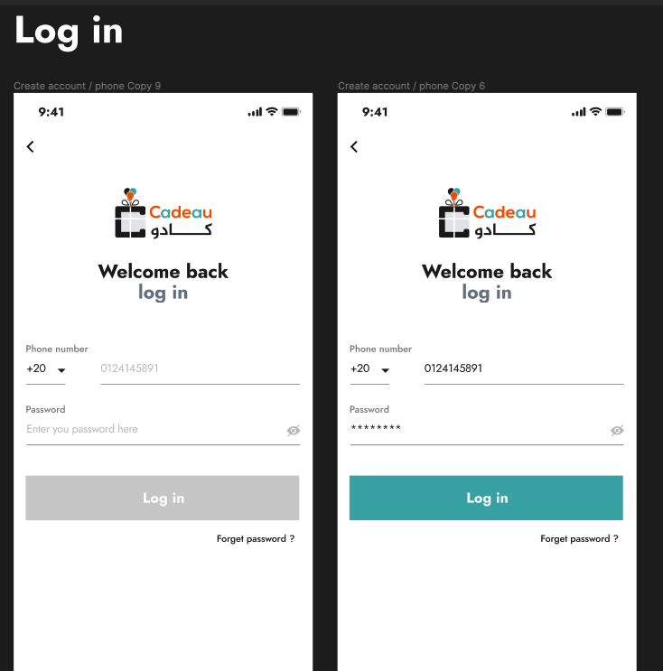

3)Forget password screen:

1. You will use the same phone number that you logged in with to write it in this field and the next button has the same functionality as login.
2. The next button in the first screen will be an API to receive the verification code.
3. You will receive a verification code and you will enter it in its place and the next button in the second screen will call another API with the entered verification code to verify it.
4. Resend code will be an API call to resend a new verification code.
5. The next button has the same functionality as above.
6. The third page is the set up of the new password ( “your password must have” is a bonus task at the end ).
7. The next button in the third screen is another call of API to change the password.

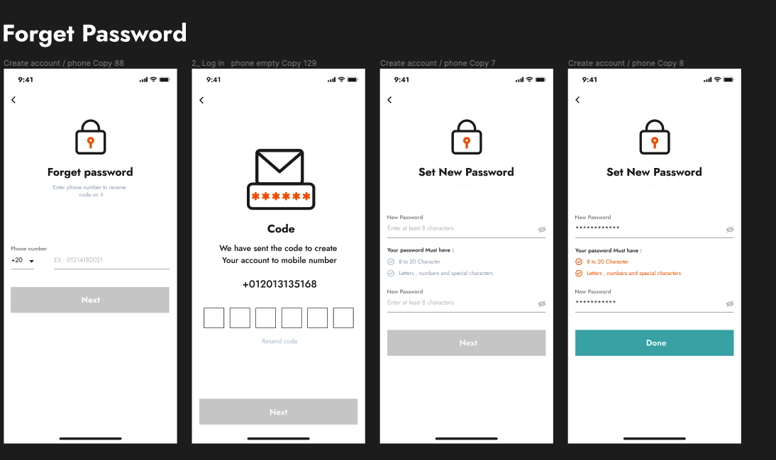

4)Occasions list screen:

1. The notification item will be static with UI only.
2. This list will include pagination (load more items when scrolling down if there is more items)
3. You will use the occasions API.

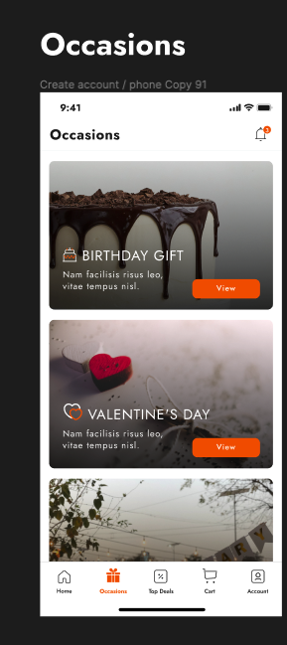

5)Occasion item screen:

1. When pressing on an occasion from the above list it will navigate you to this screen with the chosen occasion.
2. The search icon will be static UI only and the part of top offers will also be static with UI only.
3. This will be an API for products inside this occasion and it will be paginated also.
4. Don’t put the favorite icon in each product at the top right corner.

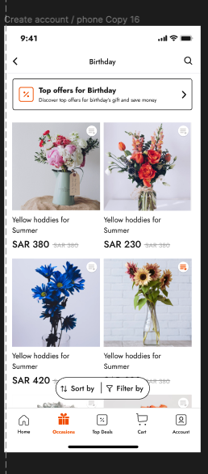

6)Account tab:

You will find only the logout exist in account tab, it should let the user logout from the application and navigate him to the login screen and each time the user open the app after the logout action it will navigate him to the login screen but if the user logged in and close and reopen the app it will navigate the user to the occasions tab by default.

7)Product details screen:

1. This will appear when clicking on a specific product item from the above list.
2. Here you will use the API for obtaining product details data.
3. You will ignore the color and size and the favorite icon at the right and the related products and recently view don’t do it,

do only all above the color and the description only and the 2 buttons at the bottom without clicking functionality.

1. The back arrow will navigate back to the occasion items screen and the share icon is static UI only.

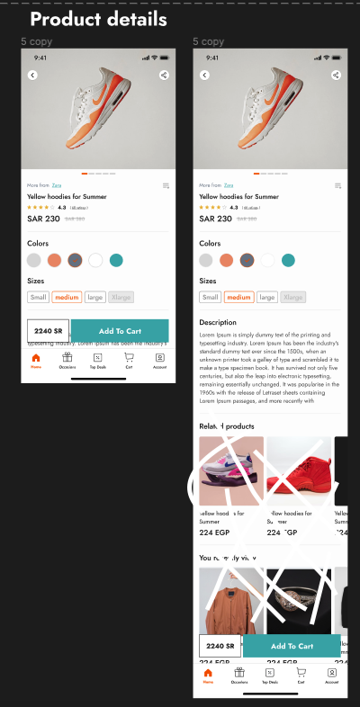

**Hints:**

* Try to create a common widget and use it in different places instead of repeating it more than once.
* Search about **packages** for using it in many **unfamiliar UI** instead of doing it from scratch for you ex: **country code picker inside login screen**
* Search about **encoding/decoding for use in API requests**.
* Search about **pagination for lists** cz you must use it inside any list.
* Make your own project structure like exist in the course for example.
* If you took more than 4 hours searching about something and you struggled, ask on the channel, don't ask in private.
* Put after the login task, estimate time on each task before starting working on it and compare it with time spent for each task in reality and tell that on channel.
* Use the last version of flutter.
* In the **navigation bottom you will have only occasions and account** don’t put the other tabs.
* Start with the login and forget password tasks and then begin with the Persistent tab view package to let the bottom navigation still exist with multiple navigation and doesn't disappear.